

**Report**

**Assignment – 01**

Course Code : CSE-0302

Course Name : Compiler Design Lab

Submitted By :

Name : Catherine Purification

ID : UG02-50-19-004

Submitted To,

Name : Khan Md.Hasib

Department of Computer Science & Engineering

Assignment #1

#include<bits/stdc++.h>

using namespace std;

#define optimize()

#define endl '\n'

int main()

{

ios_base::sync_with_stdio(false);

cin.tie(NULL);

cout.tie(0);

optimize();

FILE *input;

FILE *output;

string s;

char p;

input=fopen("input.txt","r");

output=fopen("output.txt","w");

while(!feof(input))

{

p=getc(input);

s+=p;

}

cout<<s;

cout<<endl;

for(int i=0; i<s.size(); i++)

{

if(s[i]=='/' && s[i+1]=='/')

while(s[i]!='\n')

{

i++;

}

else if (s[i]=='*')

while(s[i]!='/')

i++;

else if(s[i]!=32 && s[i]!=9 && s[i]!='\n' && s[i]!='/' && s[i]!='*')

{

if (s[i-1]=='}')

continue;

cout<<s[i];

fputc(s[i],output);

}

}

fclose(input);

fclose(output);

return 0;

}

Sample Input :

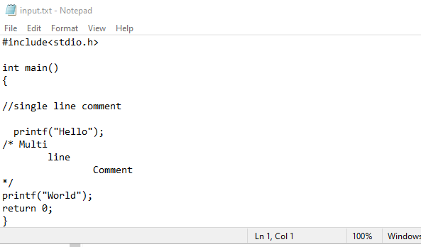

Sample Output :

